**Assessment Three Monitor Project**

**Daniel Swain 21/04/2016**

**Introduction**

The following document outlines the project progress update. It details the updated milestone dates and project approach as well as demonstrating compliance with our collaboration tools and coding standards.

**Project Plan**

Please see the included updated Project Plan for an update of the project milestones, risks and assumptions. The following is a summary of the project as of the 21/04/2016.

Sprint 1 – Initial Design (Status – Completed 29/03/2016):

* Completed Design Index Page
* Completed Design Sell Pages
* Completed Design Listing Management Page
* Completed Design User Login/Signup
* Completed Design User Dashboard
* Completed Design Contact Page
* Completed Draft Terms of Condition and Privacy Policy
* Completed Design Individual Property Page
* Completed Design Seller’s Listings Page
* Completed Design Search Results Page

Sprint 2 – Initial Development (Status – Due 27/04/2016)

The following tasks from Sprint 2 have been completed.

* Project Setup including:
  + Rails project configured
  + Controllers generated
  + MySQL database created
  + MySQL database connected to Rails Application
  + Sass and Coffeescript files set up in directory
* Layout of Seller’s Pages including:
  + Advertising View shown when not logged in
  + Manage Listings View shown when logged in and have listings
  + Add Listing Page Layout
  + Edit Listing Page Layout
  + Edit Listing Status Modal Layout
* Layout of Index Page including:
  + Index page layout
  + Main application.html.erb
  + Header and Footer layouts
* Layout of User Login/Sign-up modal
* Layout of Contact Page
* Draft Layout of User Dashboard
* Conversion of Privacy Policy and Terms and Conditions to html.erb documents
* The following functions/utilities
  + Date/Time Pickers using JQuery, pickatime.js and pickadate.js
  + Infinite Scroll implemented on Seller Listing Management Page
  + Connection of Seller Listing Page with MySQL database (read only)
  + Connection of Edit Seller Listing Page with MySQL database (read only)
  + Connection of Edit Listing Status Modal with MySQL database (read only)
  + Styling of Nav bar changes based upon active page
  + Links between pages built
  + User, Listing, ListingImage, ListingStatus and TagType models created and connected to MySQL database (no relations yet)
  + Implementing of Google Maps API which will be used on the Property listing page in a future sprint.

The following tasks from Sprint 2 have yet to be completed (as of 21/04/2016)

* Image Carousel to be used on Property Page and Index Page (Actively being worked on as of this update)
* Image Upload Function (may be pushed to sprint 3)
* Mail Server for contact page (may be pushed to sprint 3)
* User Login/Sign-up Function (Actively being worked on as of this update, using Rails gem Devise, UI Designed and functional, ready to be tied into function)
* Scroll to Top of page function (Unsure of development status)
* Custom Social feed for Index Page (Unsure of development status)

Milestone Updates

Unfortunately, due to delays in presenting designs to the client, and difficulty in obtaining client feedback, we have extended various project milestones to increase the development time available to us. This has the unfortunate downside of reducing testing time from the initial estimate. The following represent the updated project milestones

* Design completed by 30th March (was 9th March)
* Client Approval completed by 6th April (was 16th March)
* Development completed by 25th May (was 27th April)
* Testing completed by 7th June (was 18th May)
* Final Delivery completed by 9th June (unchanged)

Changes to Approach

The following changes to the project approach have been implemented due to response from the client and lecturers:

* Can continue using Semantic-UI as the Front End Framework of choice however:
* Must utilise Foundation as the Front End Framework for the admin page
* Are using all our initial designs, but were not chosen as preferred design for the following pages, as such, we’re utilising our design language to build these pages:
  + Search results page (Client preferred the sidebar design)
  + Property listing page (Client liked the layout)
* Our logo was not chosen, as such we will change to the chosen logo when the client has decided on the final name for the project (to minimise rework)

**Collaboration**

For collaboration we are still using Trello, Slack and Github. We have found Slack to be the most used tool for discussion, with Github being useful for highlighting issues, bugs and feature requests. Trello is being used by the Scrum Manager to mark sprint progress and add tasks for the backlog for future tasks. Note, for convenience, we have utilised a tool called Zapier to automatically create Slack Messages and Trello Cards based upon Github issues and merge requests to ensure all team members are notified.

The following are examples of the collaboration tools being used:

Slack (showing the Zapier channel which posts our git commits):

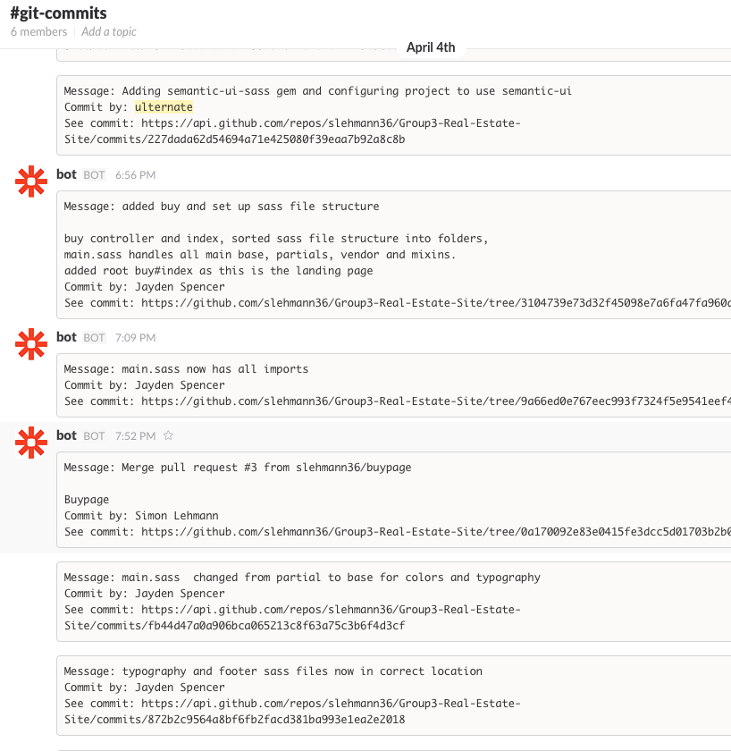

Trello (showing Sprint tracking):

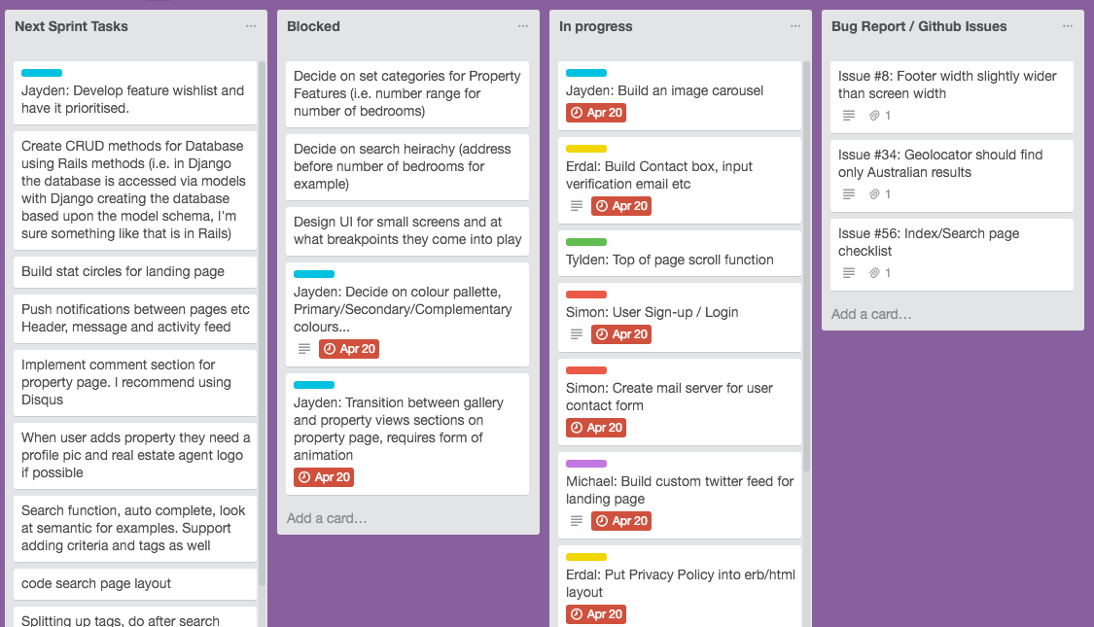

Github (showing an Issue being actioned):

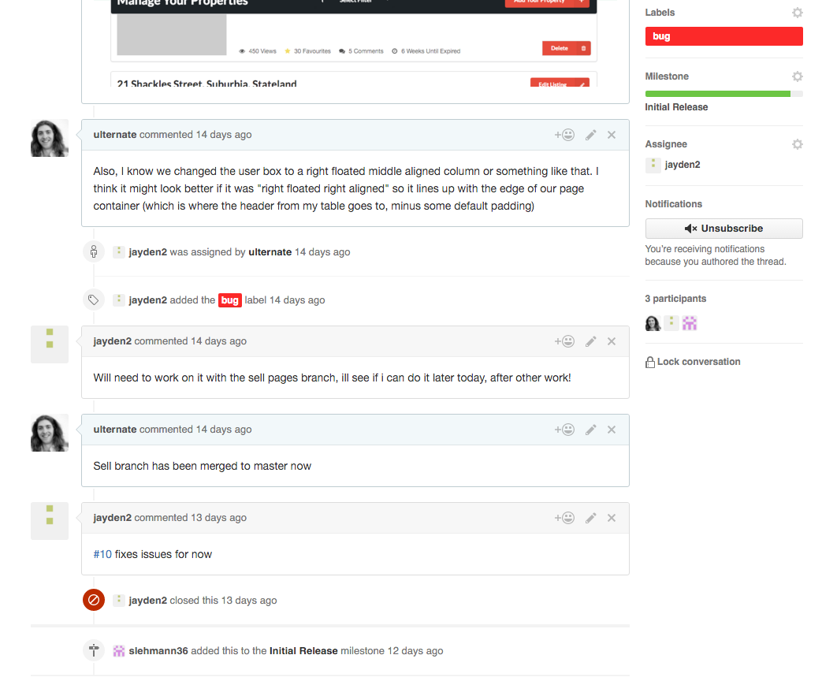

**Coding Standards:**

The coding standards we implemented can be found here: <https://drive.google.com/open?id=18F52kEOdb0eG1TtQPi_kskgJIjToppe2-23_J8VWmzw>

The following images demonstrate these coding standards being followed in various languages:

Image 1 – sell_controller.rb:

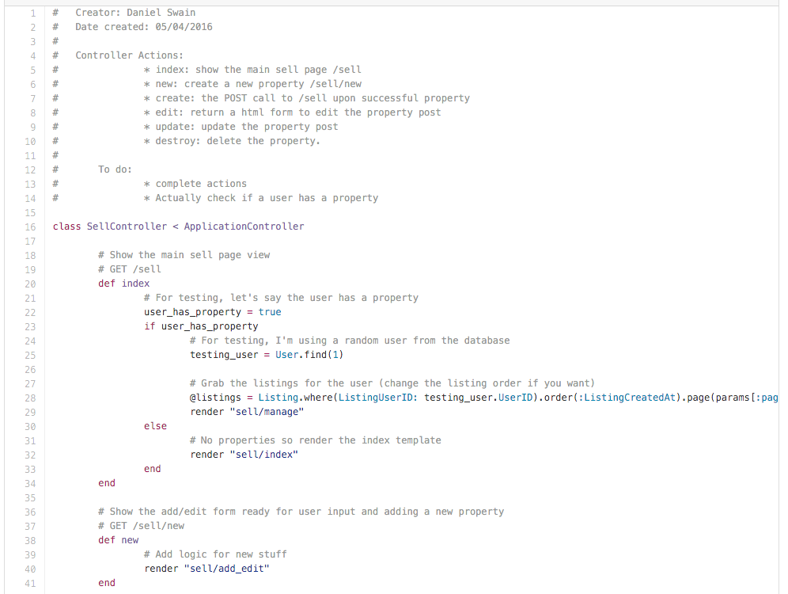

Notes:

* Documented with creator, date, action explanation and todo
* Aligned in accordance with coding standard
* Variables named in accordance with coding standard (snake_case)
* NB (the database column names were created using CamelCase)

Image 2 – _sell.sass:

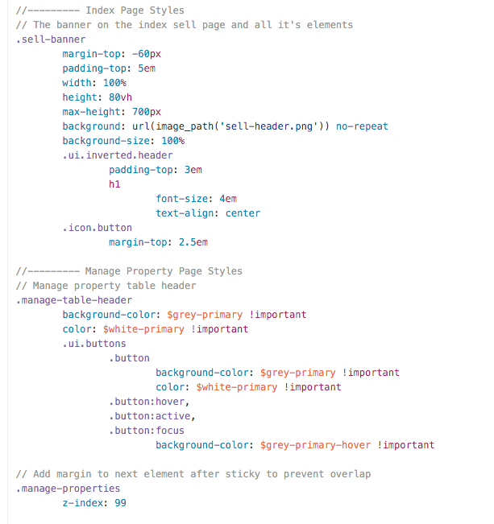

Notes:

* Documented with explanations for style definitions
* Aligned in accordance with coding standard
* Using correct variables for global variables like colours (colour-shade-action)
* Using ‘em’s as much as possible (unavoidable for the banner height and top margin)

Image 3 – _manage_property_status_modal.html.erb:

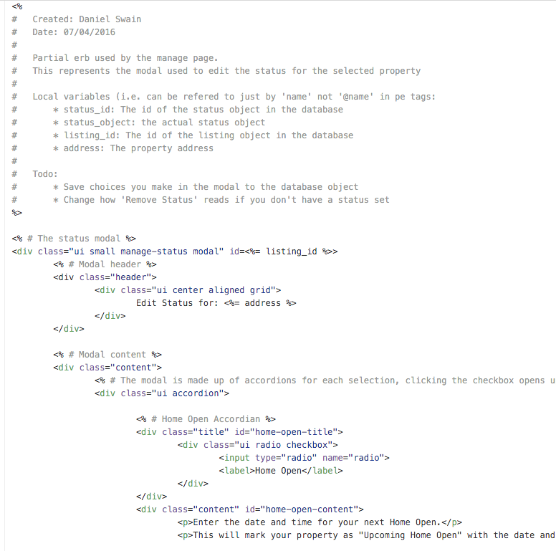

Notes:

* Documented with creator, date, explanations and todo
* Aligned in accordance with coding standard
* Using snake_case for ruby variables and hyphen for html id’s/classes

Image 4 – sell.coffee:

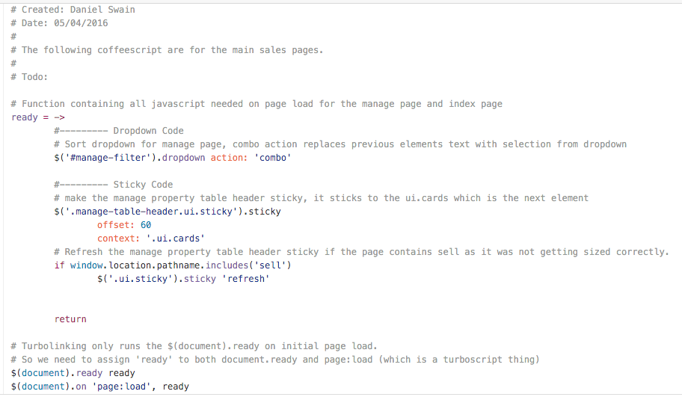

Notes:

* Documented with creator, date, explanations and todo
* Aligned in accordance with coding standard